

Spring 2026

Name: Adil Khan
Roll no: 2610-4011
Department: BS AI

Task no 1:
Output:
8
Output:
Max=50
Max=501

Output:
In this we use double instead of float
4

Task no 2:
#include <iostream>
using namespace std;

int factorial(int n)
{
if (n == 0 || n == 1)
return 1;
else
return n * factorial(n - 1);
}

int main()
{
int num;

cout << "Enter a number: ";
cin >> num;

if (num < 0)
cout << "Factorial is not defined for negative numbers.";
else
cout << "Factorial of " << num << " is " << factorial(num);

return 0;
}

Output:
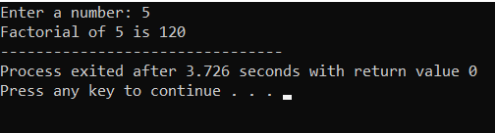

Task no 3:
#include <iostream>
using namespace std;

int fibonacci(int n)
{
if (n == 0)
return 0;
if (n == 1)
return 1;

return fibonacci(n - 1) + fibonacci(n - 2);
}

int main()
{
int terms;

cout << "Enter how many Fibonacci terms you want: ";
cin >> terms;

if (terms <= 0)
{
cout << "Please enter a positive number.";
}
else
{
cout << "Fibonacci Series: ";

for (int i = 0; i < terms; i++)
{
cout << fibonacci(i) << " ";
}
}

return 0;
}

Output:
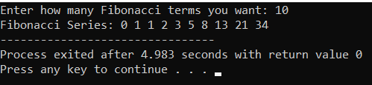

Task no 4:
#include <iostream>
using namespace std;

int power(int base, int exponent)
{
if (exponent == 0)

return 1;
return base * power(base, exponent - 1);
}

int main()
{
int base, exponent;

cout << "Enter the base: ";
cin >> base;

cout << "Enter the exponent: ";
cin >> exponent;

if (exponent < 0)
cout << "Please enter a non-negative exponent.";
else
cout << "Result = " << power(base, exponent);

return 0;
}

Output:
